Section 11B-234 Amusement Rides
11B-234.1 General
Amusement rides shall comply with Section 11B-234.
Exception: Mobile or portable amusement rides shall not be required to comply with Section 11B-234.
11B-234.2 Load and Unload Areas
Load and unload areas serving amusement rides shall comply with Section 11B-1002.3.
11B-234.3 Minimum Number
Amusement rides shall provide at least one wheelchair space complying with Section 11B-1002.4, or at least one amusement ride seat designed for transfer complying with Section 11B-1002.5, or at least one transfer device complying with Section 11B-1002.6.
Exceptions:
- Amusement rides that are controlled or operated by the rider shall not be required to comply with Section 11B-234.3.
- Amusement rides designed primarily for children, where children are assisted on and off the ride by an adult, shall not be required to comply with Section 11B-234.3.
- Amusement rides that do not provide amusement ride seats shall not be required to comply with Section 11B-234.3.
11B-234.4 Existing Amusement Rides
Where existing amusement rides are altered, the alteration shall comply with Section 11B-234.4.
11B-234.4.1 Load and Unload Areas
Where load and unload areas serving existing amusement rides are newly designed and constructed, the load and unload areas shall comply with Section 11B-1002.3.
11B-234.4.2 Minimum Number
Where the structural or operational characteristics of an amusement ride are altered to the extent that the amusement ride's performance differs from that specified by the manufacturer or the original design, the amusement ride shall comply with Section 11B-234.3.
Section 11B-235 Recreational Boating Facilities
11B-235.1 General
Recreational boating facilities shall comply with Section 11B-235.
11B-235.2 Boat Slips
Boat slips complying with Section 11B-1003.3.1 shall be provided in accordance with Table 11B-235.2. Where the number of boat slips is not identified, each 40 feet (12192 mm) of boat slip edge provided along the perimeter of the pier shall be counted as one boat slip for the purpose of this section.
TABLE 11B-235.2—
BOAT SLIPS
TOTAL NUMBER OF BOAT SLIPS PROVIDED IN FACILITY | MINIMUM NUMBER OF REQUIRED ACCESSIBLE BOAT SLIPS
1 to 25 | 1
26 to 50 | 2
51 to 100 | 3
101 to 150 | 4
151 to 300 | 5
301 to 400 | 6
401 to 500 | 7
501 to 600 | 8
601 to 700 | 9
701 to 800 | 10
801 to 900 | 11
901 to 1000 | 12
1001 and over | 12, plus 1 for every 100, or fraction thereof, over 1000
11B-235.2.1 Dispersion
Boat slips complying with Section 11B-1003.3.1 shall be dispersed throughout the various types of boat slips provided. Where the minimum number of boat slips required to comply with Section 11B-1003.3.1 has been met, no further dispersion shall be required.
11B-235.3 Boarding Piers at Boat Launch Ramps
Where boarding piers are provided at boat launch ramps, at least 5 percent, but no fewer than one, of the boarding piers shall comply with Section 11B-1003.3.2.
Section 11B-236 Exercise Machines and Equipment
11B-236.1 General
At least one of each type of exercise machine and equipment shall comply with Section 11B-1004.
Section 11B-237 Fishing Piers and Platforms
11B-237.1 General
Fishing piers and platforms shall comply with Section 11B-1005.
Section 11B-238 Golf Facilities
11B-238.1 General
Golf facilities shall comply with Section 11B-238.
11B-238.2 Golf Courses
Golf courses shall comply with Section 11B-238.2.
11B-238.2.1 Teeing Grounds
Where one teeing ground is provided for a hole, the teeing ground shall be designed and constructed so that a golf car can enter and exit the teeing ground. Where two teeing grounds are provided for a hole, the forward teeing ground shall be designed and constructed so that a golf car can enter and exit the teeing ground. Where three or more teeing grounds are provided for a hole, at least two teeing grounds, including the forward teeing ground, shall be designed and constructed so that a golf car can enter and exit each teeing ground.
Exception: In existing golf courses, the forward teeing ground shall not be required to be one of the teeing grounds on a hole designed and constructed so that a golf car can enter and exit the teeing ground where compliance is not feasible due to terrain.
11B-238.2.2 Putting Greens
Putting greens shall be designed and constructed so that a golf car can enter and exit the putting green.
11B-238.2.3 Weather Shelters
Where provided, weather shelters shall be designed and constructed so that a golf car can enter and exit the weather shelter and shall comply with Section 11B-1006.4.
11B-238.3 Practice Putting Greens, Practice Teeing Grounds and Teeing Stations at Driving Ranges
At least 5 percent, but no fewer than one, of practice putting greens, practice teeing grounds and teeing stations at driving ranges shall be designed and constructed so that a golf car can enter and exit the practice putting greens, practice teeing grounds and teeing stations at driving ranges.
Section 11B-239 Miniature Golf Facilities
11B-239.1 General
Miniature golf facilities shall comply with Section 11B-239.
11B-239.2 Minimum Number
At least 50 percent of holes on miniature golf courses shall comply with Section 11B-1007.3.
11B-239.3 Miniature Golf Course Configuration
Miniature golf courses shall be configured so that the holes complying with Section 11B-1007.3 are consecutive. Miniature golf courses shall provide an accessible route from the last hole complying with Section 11B-1007.3 to the course entrance or exit without requiring travel through any other holes on the course.
Exception: One break in the sequence of consecutive holes shall be permitted provided that the last hole on the miniature golf course is the last hole in the sequence.
Section 11B-240 Play Areas
11B-240.1 General
Play areas for children ages 2 and over shall comply with Section 11B-240. Where separate play areas are provided within a site for specific age groups, each play area shall comply with Section 11B-240.
Exceptions:
- Play areas located in family child-care facilities where the proprietor actually resides shall not be required to comply with Section 11B-240.
- In existing play areas, where play components are relocated for the purposes of creating safe use zones and the ground surface is not altered or extended for more than one use zone, the play area shall not be required to comply with Section 11B-240.
- Amusement attractions shall not be required to comply with Section 11B-240.
- Where play components are altered and the ground surface is not altered, the ground surface shall not be required to comply with Section 11B-1008.2.6 unless required by Section 11B-202.4.
11B-240.1.1 Additions
Where play areas are designed and constructed in phases, the requirements of Section 11B-240 shall apply to each successive addition so that when the addition is completed, the entire play area complies with all the applicable requirements of Section 11B-240.
11B-240.2 Play Components
Where provided, play components shall comply with Section 11B-240.2.
11B-240.2.1 Ground Level Play Components
Ground level play components shall be provided in the number and types required by Section 11B-240.2.1. Ground level play components that are provided to comply with Section 11B-240.2.1.1 shall be permitted to satisfy the additional number required by Section 11B-240.2.1.2 if the minimum required types of play components are satisfied. Where two or more required ground level play components are provided, they shall be dispersed throughout the play area and integrated with other play components.
11B-240.2.1.1 Minimum Number and Types
Where ground level play components are provided, at least one of each type shall be on an accessible route and shall comply with Section 11B-1008.4.
11B-240.2.1.2 Additional Number and Types
Where elevated play components are provided, ground level play components shall be provided in accordance with Table 11B-240.2.1.2 and shall comply with Section 11B-1008.4.
Exception: If at least 50 percent of the elevated play components are connected by a ramp and at least 3 of the elevated play components connected by the ramp are different types of play components, the play area shall not be required to comply with Section 11B-240.2.1.2.
TABLE 11B-240.2.1.2—
NUMBER AND TYPES OF GROUND LEVEL PLAY COMPONENTS REQUIRED TO BE ON ACCESSIBLE ROUTES
NUMBER OF ELEVATED  PLAY COMPONENTS PROVIDED | MINIMUM NUMBER OF REQUIRED  ACCESSIBLE BOAT SLIPS | MINIMUM NUMBER OF DIFFERENT TYPES OF  GROUND LEVEL PLAY COMPONENTS REQUIRED  TO BE ON AN ACCESSIBLE ROUTE
1 | Not applicable | Not applicable
2 to 4 | 1 | 1
5 to 7 | 2 | 2
8 to 10 | 3 | 3
11 to 13 | 4 | 3
14 to 16 | 5 | 3
17 to 19 | 6 | 3
20 to 22 | 7 | 4
23 to 25 | 8 | 4
26 and over | 8, plus 1 for each additional 3,  or fraction thereof, over 25 | 5
11B-240.2.2 Elevated Play Components
Where elevated play components are provided, at least 50 percent shall be on an accessible route and shall comply with Section 11B-1008.4.
Section 11B-241 Saunas and Steam Rooms
11B-241.1 General
Where provided, saunas and steam rooms shall comply with Section 11B-612.
Exception: Where saunas or steam rooms are clustered at a single location, no more than 5 percent of the saunas and steam rooms, but no fewer than one, of each type in each cluster shall be required to comply with Section 11B-612.
Section 11B-242 Swimming Pools, Wading Pools and Spas
11B-242.1 General
Swimming pools, wading pools and spas shall comply with Section 11B-242.
11B-242.2 Swimming Pools
At least two accessible means of entry shall be provided for swimming pools. Accessible means of entry shall be swimming pool lifts complying with Section 11B-1009.2; sloped entries complying with Section 11B-1009.3; transfer walls complying with Section 11B-1009.4; transfer systems complying with Section 11B-1009.5; and pool stairs complying with Section 11B-1009.6. At least one accessible means of entry provided shall comply with Sections 11B-1009.2 or 11B-1009.3.
Exceptions:
- Where a swimming pool has less than 300 linear feet (91 m) of swimming pool wall, no more than one accessible means of entry shall be required provided that the accessible means of entry is a swimming pool lift complying with Section 11B-1009.2 or sloped entry complying with Section 11B-1009.3.
- Wave action pools, leisure rivers, sand bottom pools and other pools where user access is limited to one area shall not be required to provide more than one accessible means of entry provided that the accessible means of entry is a swimming pool lift complying with Section 11B-1009.2, a sloped entry complying with Section 11B-1009.3, or a transfer system complying with Section 11B-1009.5.
- Catch pools shall not be required to provide an accessible means of entry provided that the catch pool edge is on an accessible route.
11B-242.3 Wading Pools
At least one accessible means of entry shall be provided for wading pools. Accessible means of entry shall comply with sloped entries complying with Section 11B-1009.3.
11B-242.4 Spas
At least one accessible means of entry shall be provided for spas. Accessible means of entry shall comply with swimming pool lifts complying with Section 11B-1009.2; transfer walls complying with Section 11B-1009.4; or transfer systems complying with Section 11B-1009.5.
Exception: Where spas are provided in a cluster, no more than 5 percent, but no fewer than one, spa in each cluster shall be required to comply with Section 11B-242.4.
Section 11B-243 Shooting Facilities With Firing Positions
11B-243.1 General
Where shooting facilities with firing positions are designed and constructed at a site, at least 5 percent, but no fewer than one, of each type of firing position shall comply with Section 11B-1010.
Section 11B-244 Religious Facilities
11B-244.1 General
Religious facilities shall be accessible in accordance with the provisions of this code. Where specific areas within religious facilities contain more than one use, each portion shall comply with the applicable requirements for that use.
Section 11B-245 Public Accommodations Located in Private Residences
11B-245.1 General
Public accommodations located in private residences shall comply with Section 11B-245.
11B-245.2 Application
When a public accommodation is located in a private residence, that portion used exclusively in the operation of the public accommodation or that portion used both for the public accommodation and for residential purposes is covered by the new construction and alterations requirements of this chapter.
Exception: The portion of the residence used exclusively as a residence is not required to be accessible in accordance with this chapter.
11B-245.3 Accessible Elements Required
The accessible portion of the residence extends to those elements used to enter the public accommodation, including the front sidewalk, if any, the door or entryway, and hallways; and those portions of the residence, interior or exterior, available to or used by employees or visitors of the public accommodation, including restrooms.
Section 11B-246 Outdoor Developed Areas
11B-246.1 General
Outdoor developed areas shall comply with Section 11B-246.
Exceptions:
- Where the enforcing agency finds that, in specific areas, the natural environment would be materially damaged by compliance with these regulations, such areas shall be subject to these regulations only to the extent that such material damage would not occur.
- Automobile access or accessible routes are not required when the enforcing agency determines compliance with this chapter would create an unreasonable hardship as defined in Chapter 2, Section 202.
11B-246.2 Camping Facilities
In camping facilities where campsites are provided, at least two campsites and one additional campsite for each 100 campsites or fraction thereof, shall be accessed by and connected to sanitary facilities by travel routes with a maximum slope of 1:12. Permanent toilet and bathing facilities serving campsites shall comply with Section 11B-603.
11B-246.3 Beaches
Beaches shall be accessible.
11B-246.4 Day Use Areas and Vista Points
Day use areas, vista points and similar areas shall be accessible.
11B-246.5 Picnic Areas
Where picnic tables are provided, at least one picnic table, and one additional table for each 20 tables or fraction thereof, shall be accessible and comply with Section 11B-902.
11B-246.6 Parking Lots
Parking lots shall comply with Sections 11B-208 and 11B-502 and shall be provided with curb cuts leading to adjacent walks, paths or trails.
11B-246.7 Trails and Paths
Trails, paths and nature walk areas, or portions of them, shall be constructed with gradients permitting at least partial use by wheelchair occupants. Buildings and other functional areas shall be served by paths or walks with firm and stable surfaces.
11B-246.8 Nature Trails
Nature trails and similar educational and informational areas shall be accessible to individuals with vision impairments by the provision of rope guidelines, raised Arabic numerals and symbols, or other similar guide and assistance devices.
Section 11B-247 Detectable Warnings and Detectable Directional Texture
11B-247.1 Detectable Warnings
11B-247.1.1 General
Detectable warnings shall be provided in accordance with Section 11B-247.1 and shall comply with Section 11B-705.1.
11B-247.1.2 Where Required
Detectable warnings shall be provided where required by Section 11B-247.1.2.
11B-247.1.2.1 Platform Edges
Platform boarding edges shall have detectable warnings complying with Sections 11B-705.1.1 and 11B-705.1.2.1.
11B-247.1.2.2 Curb Ramps
Curb ramps shall have detectable warnings complying with Sections 11B-705.1.1 and 11B-705.1.2.2.
11B-247.1.2.3 Islands or Cut-Through Medians
Islands or cut-through medians shall have detectable warnings complying with Sections 11B-705.1.1 and 11B-705.1.2.3.
11B-247.1.2.4 Bus Stops
Where detectable warnings are provided at bus stop boarding and alighting areas in compliance with Section 11B-810.2.3, detectable warnings shall comply with Sections 11B-705.1.1 and 11B-705.1.2.4.
11B-247.1.2.5 Blended Transitions
Diagram
Blended transitions shall have detectable warnings complying with Sections 11B-705.1.1 and 11B-705.1.2.5.
UpCodes Diagram (1)
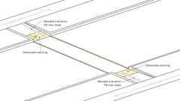
Blended Transitions
11B-247.1.2.6 Reflecting Pools
The edges of reflecting pools shall be protected by railings, walls, warning curbs or detectable warnings complying with Sections 11B-705.1.1 and 11B-705.1.2.6.
11B-247.1.2.7 Track Crossings
Where it is necessary to cross tracks to reach transit boarding platforms, detectable warnings complying with Sections 11B-705.1.1 and 11B-705.1.2.7 shall be provided.
11B-247.2 Detectable Directional Texture
At transit boarding platforms, the pedestrian access shall be identified with a detectable directional texture complying with Section 11B-705.2.
Section 11B-248 Common Use Areas and Employee Work Areas
11B-248.1 Common Use Areas
Common use areas shall comply with this chapter.
11B-248.2 Employee Work Areas
Employee work areas shall comply with this chapter.
Section 11B-249 Adult Changing Facilities
11B-249.1 General
Adult changing facilities shall comply with Section 11B-249.
11B-249.1.1
Where adult changing facilities are provided, each adult changing facility shall comply with Section 11B-813.
11B-249.1.2
Newly constructed commercial places of public amusement shall provide no fewer than one adult changing facility in compliance with Section 11B-813.
11B-249.1.3
On or after January 1, 2025, alterations to existing commercial places of public amusement which require a permit or for which the estimated cost is ten thousand dollars ($10,000) or more shall provide no fewer than one adult changing facility in compliance with Section 11B-813.
Exception: Existing commercial places of public amusement with an existing adult changing facility in compliance with Section 11B-813 shall not be required to provide additional adult changing facilities.
Section 11B-250 Circulation Paths
11B-250.1 General
Circulation paths contiguous to vehicular traffic shall be physically separated from vehicular traffic. Vehicular traffic includes travel through parking facilities, into and out of parking spaces, into and out of electric vehicle charging spaces, and along roadways, driveways and drive aisles. Physical separation shall be provided with circulation paths raised 4 inches (102 mm) minimum above the area where vehicular traffic occurs.
Exceptions:
- Curb ramps and blended transitions with detectable warnings complying with Section 11B-247 may be used to connect raised circulation paths and pedestrian crossings within areas of vehicular traffic. Blended transitions and cut-through medians with detectable warnings complying with Section 11B-247 may be used to connect circulation paths and pedestrian crossings at similar elevations within areas of vehicular traffic.
- At locations where sidewalks and walks in the public right-of-way cross driveways without yield or stop traffic control, compliance with this section shall not be required.
- At locations where circulation paths cross driveways or drive aisles, circulation paths shall not be required to comply with this section and detectable warnings shall not be permitted. Beyond the crossing where continuation of the circulation path within a parking facility leads immediately to and does not continue beyond only parking spaces complying with Section 11B-502, passenger drop-off and loading zones complying with Section 11B-503 and electric vehicle charging stations complying with Section 11B-812, the circulation path shall not be required to be raised.
- In alterations to existing parking facilities, including alterations required by Section 11B-202.4, physical separation may be provided with detectable warnings complying with Sections 11B-247 and 11B-705.1 in lieu of raised circulation paths.
- Access aisles serving any electric vehicle charging station vehicle spaces complying with Section 11B-812, parking spaces complying with Section 11B-502, or passenger drop-off and loading zones complying with Section 11B-503 shall not be required to comply with this section.
- At each electric vehicle charging station complying with Section 11B-812 where the charger and its controls are oriented toward the vehicle space it serves and the charger's clear floor spaces for operable parts and point-of-sale devices are at the same elevation as the vehicle space, the accessible route complying with Section 11B-812.5.2 shall not be required to comply with this section.
Division 3 Building Blocks
Section 11B-301 General
11B-301.1 Scope
The provisions of Division 3 shall apply where required by Division 2 or where referenced by a requirement in this chapter .
Section 11B-302 Floor or Ground Surfaces
Diagram
UpCodes Diagram (1)
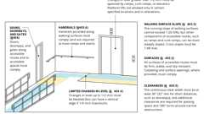
Accessible Route Components
11B-302.1 General
Diagram
Floor and ground surfaces shall be stable, firm and slip resistant and shall comply with Section 11B-302.
Exceptions:
- Within animal containment areas, floor and ground surfaces shall not be required to be stable, firm and slip resistant.
- Areas of sport activity shall not be required to comply with Section 11B-302.
UpCodes Diagram (1)
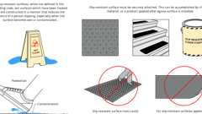
Slip-Resistant Surfaces
Building products (4)
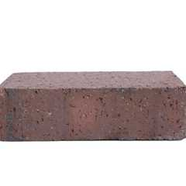
Back Up Pavers 4 x 2¼ x 7⅝
Interstate Brick

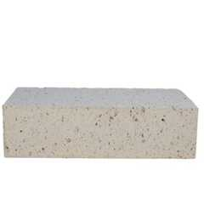
Modular Paver 4 x 2¼ x 7⅝
Interstate Brick

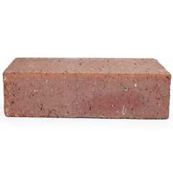
Modular Solid 4 x 2¼ x 8
Interstate Brick

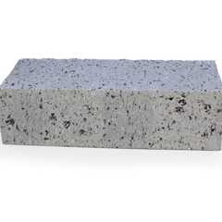
True Paver 4 x 2¼ x 8
Interstate Brick

11B-302.2 Carpet
Carpet or carpet tile shall be securely attached and shall have a firm cushion, pad, or backing or no cushion or pad. Carpet or carpet tile shall have a level loop, textured loop, level cut pile, level cut/uncut pile texture. Pile height shall be ¹/₂ inch (12.7 mm) maximum. Exposed edges of carpet shall be fastened to floor surfaces and shall have trim on the entire length of the exposed edge. Carpet edge trim shall comply with Section 11B-303.
FIGURE 11B-302.2—CARPET PILE HEIGHT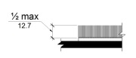
11B-302.3 Openings
Openings in floor or ground surfaces shall not allow passage of a sphere more than ¹/₂ inch (12.7 mm) diameter except as allowed in Sections 11B-407.4.3, 11B-409.4.3, 11B-410.4, 11B-810.5.3 and 11B-810.10. Elongated openings shall be placed so that the long dimension is perpendicular to the dominant direction of travel.
FIGURE 11B-302.3—ELONGATED OPENINGS IN FLOOR OR GROUND SURFACES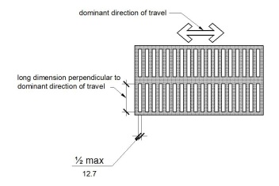
Building product (1)
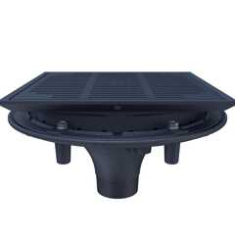
High Performance Promenade Deck Drain with Rotatable Frame and Heel-Proof Grate - Z150F
Zurn

Section 11B-303 Changes in Level
11B-303.1 General
Where changes in level are permitted in floor or ground surfaces, they shall comply with Section 11B-303.
Exceptions:
- Animal containment areas shall not be required to comply with Section 11B-303.
- Areas of sport activity shall not be required to comply with Section 11B-303.
11B-303.2 Vertical
Diagram
Changes in level of ¹/₄ inch (6.4 mm) high maximum shall be permitted to be vertical and without edge treatment.
FIGURE 11B-303.2—VERTICAL CHANGE IN LEVEL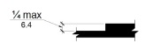
UpCodes Diagram (1)
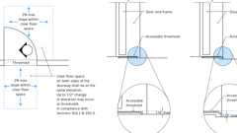Primary
Surfaces and Thresholds at Doors
11B-303.3 Beveled
Diagram
Changes in level between ¹/₄ inch (6.4 mm) high minimum and ¹/₂ inch (12.7 mm) high maximum shall be beveled with a slope not steeper than 1:2.
FIGURE 11B-303.3—BEVELED CHANGE IN LEVEL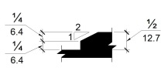
UpCodes Diagram (1)
Primary
Surfaces and Thresholds at Doors
11B-303.4 Ramps
Changes in level greater than ¹/₂ inch (12.7 mm) high shall be ramped, and shall comply with Section 11B-405 or 11B-406.
11B-303.5 Warning Curbs
Abrupt changes in level exceeding 4 inches (102 mm) in a vertical dimension between walks, sidewalks or other pedestrian ways and adjacent surfaces or features shall be identified by warning curbs at least 6 inches (152 mm) in height above the walk or sidewalk surface.
Exceptions:
- A warning curb is not required between a walk or sidewalk and an adjacent street or driveway.
- A warning curb is not required when a guard or handrail is provided with a guide rail centered 2 inches (51 mm) minimum and 4 inches (102 mm) maximum above the surface of the walk or sidewalk.
Section 11B-304 Turning Space
Diagram
UpCodes Diagrams (4)
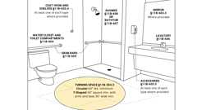
Accessible Bathing Facilities (11B)
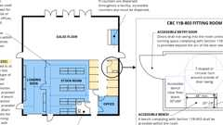
Retail (CA 11B)
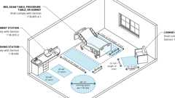
Exam, Diagnostic and Treatment Room
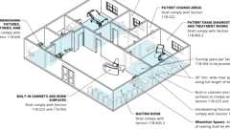
Professional Offices of Health Care Providers
11B-304.1 General
Turning space shall comply with Section 11B-304.
11B-304.2 Floor or Ground Surfaces
Floor or ground surfaces of a turning space shall comply with Section 11B-302. Changes in level, slopes exceeding 1:48, and detectable warnings shall not be permitted.
Exception: Reserved.
11B-304.3 Size
Turning space shall comply with Section 11B-304.3.1 or 11B-304.3.2.
11B-304.3.1 Circular Space
Diagram
The turning space shall be a space of 60 inches (1524 mm) diameter minimum. The space shall be permitted to include knee and toe clearance complying with Section 11B-306.
UpCodes Diagrams (2)
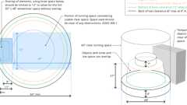Primary
Turning Space: 60” Round
Accessible Bathing Facilities (11B)
11B-304.3.2 T-Shaped Space
Diagram
The turning space shall be a T-shaped space within a 60 inch (1524 mm) square minimum with arms and base 36 inches (914 mm) wide minimum. Each arm of the T shall be clear of obstructions 12 inches (305 mm) minimum in each direction and the base shall be clear of obstructions 24 inches (610 mm) minimum. The space shall be permitted to include knee and toe clearance complying with Section 11B-306 only at the end of either the base or one arm.
FIGURE 11B-304.3.2—
T-SHAPED TURNING SPACE
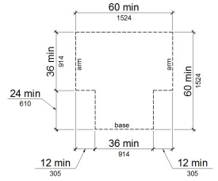
UpCodes Diagrams (2)
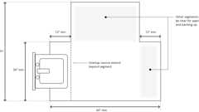Primary
T-Shaped Turning Space
Accessible Bathing Facilities (11B)
11B-304.4 Door Swing
Doors shall be permitted to swing into turning spaces.
Section 11B-305 Clear Floor or Ground Space
Diagram
UpCodes Diagram (1)
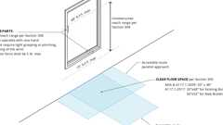
Accessible Windows: Operable Parts
11B-305.1 General
Clear floor or ground space shall comply with Section 11B-305.
11B-305.2 Floor or Ground Surfaces
Diagram
Floor or ground surfaces of a clear floor or ground space shall comply with Section 11B-302. Changes in level, slopes exceeding 1:48, and detectable warnings shall not be permitted.
Exception: Reserved.
UpCodes Diagram (1)
Exam, Diagnostic and Treatment Room
11B-305.3 Size
Diagram
The clear floor or ground space shall be 30 inches (762 mm) minimum by 48 inches (1219 mm) minimum.
FIGURE 11B-305.3—
CLEAR FLOOR OR GROUND SPACE
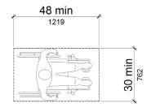
UpCodes Diagram (1)
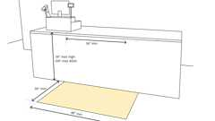
Sales and Service Counters - Parallel Approach (CA)
11B-305.4 Knee and Toe Clearance
Unless otherwise specified, clear floor or ground space shall be permitted to include knee and toe clearance complying with Section 11B-306.
11B-305.5 Position
Unless otherwise specified, clear floor or ground space shall be positioned for either forward or parallel approach to an element.
FIGURE 11B-305.5—
POSITION OF CLEAR FLOOR OR GROUND SPACE
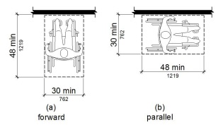
11B-305.6 Approach
One full unobstructed side of the clear floor or ground space shall adjoin an accessible route or adjoin another clear floor or ground space. Clear floor or ground space may overlap an accessible route, unless specifically prohibited elsewhere in this chapter.
11B-305.7 Maneuvering Clearance
Diagram
Where a clear floor or ground space is located in an alcove or otherwise confined on all or part of three sides, additional maneuvering clearance shall be provided in accordance with Sections 11B-305.7.1 and 11B-305.7.2.
UpCodes Diagram (1)
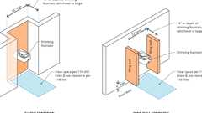
Drinking Fountains: Pedestrian Protection (11B)
11B-305.7.1 Forward Approach
Diagram
Alcoves shall be 36 inches (914 mm) wide minimum where the depth exceeds 24 inches (610 mm).
FIGURE 11B-305.7.1—
MANEUVERING CLEARANCE IN AN ALCOVE, FORWARD APPROACH
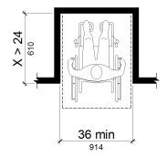
UpCodes Diagrams (2)
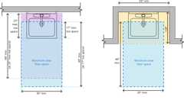Primary
Lavatory Clearances (ADA)
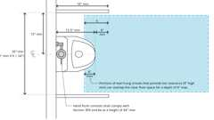
Urinals and Partitions (CA)
Building products (4)
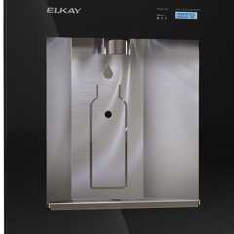
Liv® Built-in Filtered Refrigerated Water Dispenser Remote Chiller Midnight - LBWD06BKK
Elkay

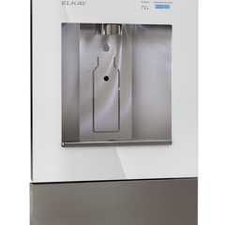
Liv® Built-in Filtered Water Dispenser Non-refrigerated Aspen White - LBWD00WHC
Elkay

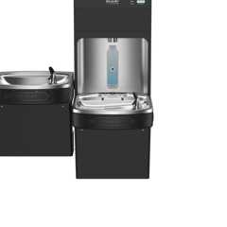
Pro Filtration® Bottle Filling Station & Bi-Level ADA Cooler Refrigerated Ultra-Capacity Lead Reduction - LZSTL8WSBPRO
Elkay

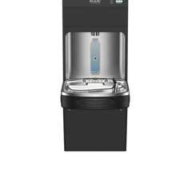
Pro Filtration® Bottle Filling Station & Single ADA Cooler Refrigerated Ultra-Capacity Lead Reduction - LZS8WSBPRO
Elkay

11B-305.7.2 Parallel Approach
Alcoves shall be 60 inches (1524 mm) wide minimum where the depth exceeds 15 inches (381 mm).
FIGURE 11B-305.7.2—
MANEUVERING CLEARANCE IN AN ALCOVE, PARALLEL APPROACH
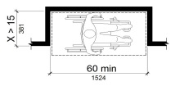
Section 11B-306 Knee and Toe Clearance
11B-306.1 General
Where space beneath an element is included as part of clear floor or ground space or turning space, the space shall comply with Section 11B-306. Additional space shall not be prohibited beneath an element but shall not be considered as part of the clear floor or ground space or turning space.
11B-306.2 Toe Clearance
FIGURE 11B-306.2—
TOE CLEARANCE
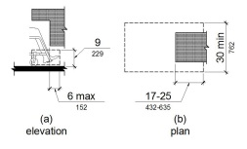
Building products (4)
Liv® Built-in Filtered Refrigerated Water Dispenser Remote Chiller Midnight - LBWD06BKK
Elkay

Liv® Built-in Filtered Water Dispenser Non-refrigerated Aspen White - LBWD00WHC
Elkay

Pro Filtration® Bottle Filling Station & Bi-Level ADA Cooler Refrigerated Ultra-Capacity Lead Reduction - LZSTL8WSBPRO
Elkay

Pro Filtration® Bottle Filling Station & Single ADA Cooler Refrigerated Ultra-Capacity Lead Reduction - LZS8WSBPRO
Elkay

11B-306.2.1 General
Space under an element between the finish floor or ground and 9 inches ( 229 mm) above the finish floor or ground shall be considered toe clearance and shall comply with Section 11B-306.2.
11B-306.2.2 Maximum Depth
Diagram
Toe clearance shall extend 25 inches (635 mm) maximum under an element.
Exception: Toe clearance shall extend 19 inches (483 mm) maximum under lavatories required to be accessible by Section 11B-213.3.4.
UpCodes Diagram (1)
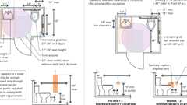
Single Toilet Room: ADA vs. CA 11B
11B-306.2.3 Minimum Required Depth
Where toe clearance is required at an element as part of a clear floor space, the toe clearance shall extend 17 inches (432 mm) minimum under the element.
Exceptions:
- The toe clearance shall extend 19 inches (483 mm) minimum under sinks required to be accessible by Section 11B-212.3.
- The toe clearance shall extend 19 inches (483 mm) minimum under built-in dining and work surfaces required to be accessible.
11B-306.2.4 Additional Clearance
Space extending greater than 6 inches (152 mm) beyond the available knee clearance at 9 inches (229 mm) above the finish floor or ground shall not be considered toe clearance.
11B-306.2.5 Width
Toe clearance shall be 30 inches (762 mm) wide minimum.
11B-306.3 Knee Clearance
FIGURE 11B-306.3—
KNEE CLEARANCE
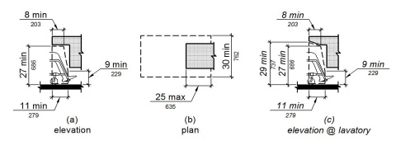
Building products (4)
Liv® Built-in Filtered Refrigerated Water Dispenser Remote Chiller Midnight - LBWD06BKK
Elkay

Liv® Built-in Filtered Water Dispenser Non-refrigerated Aspen White - LBWD00WHC
Elkay

Pro Filtration® Bottle Filling Station & Bi-Level ADA Cooler Refrigerated Ultra-Capacity Lead Reduction - LZSTL8WSBPRO
Elkay

Pro Filtration® Bottle Filling Station & Single ADA Cooler Refrigerated Ultra-Capacity Lead Reduction - LZS8WSBPRO
Elkay

11B-306.3.1 General
Space under an element between 9 inches (229 mm) and 27 inches (686 mm) above the finish floor or ground shall be considered knee clearance and shall comply with Section 11B-306.3.
Exception: At lavatories required to be accessible by Section 11B-213.3.4, space between 9 inches (229 mm) and 29 inches (737 mm) above the finish floor or ground, shall be considered knee clearance.
11B-306.3.2 Maximum Depth
Knee clearance shall extend 25 inches (635 mm) maximum under an element at 9 inches (229 mm) above the finish floor or ground.
11B-306.3.3 Minimum Required Depth
Where knee clearance is required under an element as part of a clear floor space, the knee clearance shall be 11 inches (279 mm) deep minimum at 9 inches (229 mm) above the finish floor or ground, and 8 inches (203 mm) deep minimum at 27 inches (686 mm) above the finish floor or ground.
Exceptions:
- At lavatories required to be accessible by Section 11B-213.3.4, the knee clearance shall be 27 inches (686 mm) high minimum above the finish floor or ground at a depth of 8 inches (203 mm) minimum increasing to 29 inches (737 mm) high minimum above the finish floor or ground at the front edge of a counter with a built-in lavatory or at the front edge of a wall-mounted lavatory fixture.
- At dining and work surfaces required to be accessible, knee clearance shall extend 19 inches (483 mm) deep minimum at 27 inches (686 mm) above the finish floor or ground.
11B-306.3.4 Clearance Reduction
Between 9 inches (229 mm) and 27 inches (686 mm) above the finish floor or ground, the knee clearance shall be permitted to reduce at a rate of 1 inch (25 mm) in depth for each 6 inches (152 mm) in height.
Exception: The knee clearance shall not be reduced at built-in dining and work surfaces required to be accessible by Section 11B-226.1.
11B-306.3.5 Width
Knee clearance shall be 30 inches (762 mm) wide minimum.
Section 11B-307 Protruding Objects
Diagram
UpCodes Diagrams (2)
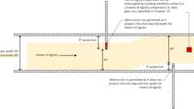
Means of Egress Continuity: Obstructions
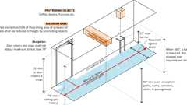
Protruding Objects: Headroom
11B-307.1 General
Protruding objects shall comply with Section 11B-307.
11B-307.2 Protrusion Limits
Diagram
Objects with leading edges more than 27 inches (686 mm) and not more than 80 inches (2032 mm) above the finish floor or ground shall protrude 4 inches (102 mm) maximum horizontally into the circulation path.
Exception: Handrails shall be permitted to protrude 4¹/₂ inches (114 mm) maximum.
FIGURE 11B-307.2—
LIMITS OF PROTRUDING OBJECTS
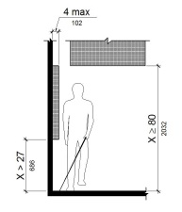
UpCodes Diagrams (3)
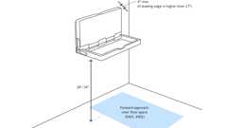
Baby Changing Tables
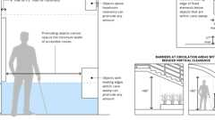
Protruding Object Limits
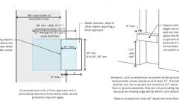
Recessed Objects
Building products (4)
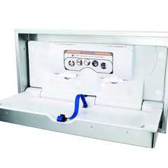
DryBaby - ABC-300HSR
World Dryer

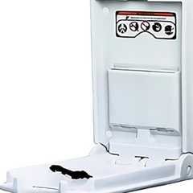
DryBaby® - ABC-300V
World Dryer

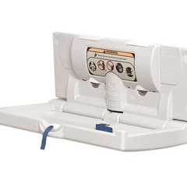
DryBaby® - ABC-300H
World Dryer

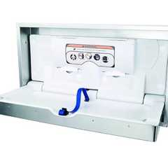
DryBaby® - ABC-300HS
World Dryer

11B-307.3 Post-Mounted Objects
Diagram
Free-standing objects mounted on posts or pylons shall overhang circulation paths 12 inches (305 mm) maximum when located 27 inches (686 mm) minimum and 80 inches (2032 mm) maximum above the finish floor or ground. Where a sign or other obstruction is mounted between posts or pylons and the clear distance between the posts or pylons is greater than 12 inches (305 mm), the lowest edge of such sign or obstruction shall be 27 inches (686 mm) maximum or 80 inches (2032 mm) minimum above the finish floor or ground.
Exception: The sloping portions of handrails serving stairs and ramps shall not be required to comply with Section 11B-307.3.
FIGURE 11B-307.3—
POST-MOUNTED PROTRUDING OBJECTS
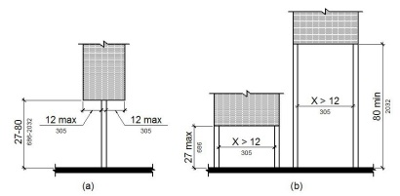
UpCodes Diagram (1)
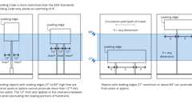Primary
Post Mounted Objects
11B-307.3.1 Edges and Corners
Where signs or other objects are mounted on posts or pylons, and their bottom edges are less than 80 inches (2032 mm) above the floor or ground surface, the edges of such signs and objects shall be rounded or eased and the corners shall have a minimum radius of ¹/₈ inch (3.2 mm).
11B-307.4 Vertical Clearance
Vertical clearance shall be 80 inches (2032 mm) high minimum. Guardrails or other barriers shall be provided where the vertical clearance is less than 80 inches (2032 mm) high. The leading edge of such guardrail or barrier shall be located 27 inches (686 mm) maximum above the finish floor or ground.
Exception: Door closers and door stops shall be permitted to be 78 inches (1981 mm) minimum above the finish floor or ground.
FIGURE 11B-307.4—
VERTICAL CLEARANCE
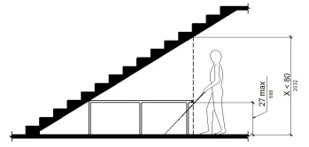
11B-307.4.1 Guy Braces
Where a guy support is used within either the width of a circulation path or 24 inches (610 mm) maximum outside of a circulation path, a vertical guy brace, sidewalk guy or similar device shall be used to prevent a hazard or an overhead obstruction.
FIGURE 11B-307.4.1—GUY BRACES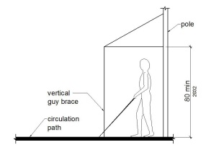
11B-307.5 Required Clear Width
Protruding objects shall not reduce the clear width required for accessible routes.
Section 11B-308 Reach Ranges
11B-308.1 General
Diagram
Reach ranges shall comply with Section 11B-308.
UpCodes Diagram (1)
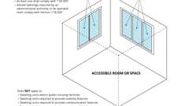
Accessible Windows (CA 11B)
11B-308.1.1 Electrical Switches
Diagram
Controls and switches intended to be used by the occupant of a room or area to control lighting and receptacle outlets, appliances or cooling, heating and ventilating equipment, shall comply with Section 11B-308 except the low reach shall be measured to the bottom of the outlet box and the high reach shall be measured to the top of the outlet box.
UpCodes Diagram (1)
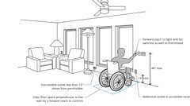
Accessible Switch, Outlet & Control Locations (CA)
11B-308.1.2 Electrical Receptacle Outlets
Diagram
Electrical receptacle outlets on branch circuits of 30 amperes or less and communication system receptacles shall comply with Section 11B-308 except the low reach shall be measured to the bottom of the outlet box and the high reach shall be measured to the top of the outlet box.
UpCodes Diagram (1)
Accessible Switch, Outlet & Control Locations (CA)
11B-308.2 Forward Reach
Diagram
UpCodes Diagram (1)
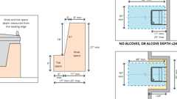
Drinking Fountain Clearances
11B-308.2.1 Unobstructed
Where a forward reach is unobstructed, the high forward reach shall be 48 inches (1219 mm) maximum and the low forward reach shall be 15 inches (381 mm) minimum above the finish floor or ground.
FIGURE 11B-308.2.1—
UNOBSTRUCTED FORWARD REACH
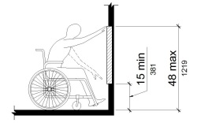
11B-308.2.2 Obstructed High Reach
Where a high forward reach is over an obstruction, the clear floor space shall extend beneath the element for a distance not less than the required reach depth over the obstruction. The high forward reach shall be 48 inches (1219 mm) maximum where the reach depth is 20 inches (508 mm) maximum. Where the reach depth exceeds 20 inches (508 mm), the high forward reach shall be 44 inches (1118 mm) maximum and the reach depth shall be 25 inches (635 mm) maximum.
FIGURE 11B-308.2.2—
OBSTRUCTED HIGH FORWARD REACH
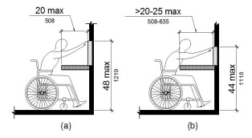
Building products (4)
Liv® Built-in Filtered Refrigerated Water Dispenser Remote Chiller Midnight - LBWD06BKK
Elkay

Liv® Built-in Filtered Water Dispenser Non-refrigerated Aspen White - LBWD00WHC
Elkay

Pro Filtration® Bottle Filling Station & Bi-Level ADA Cooler Refrigerated Ultra-Capacity Lead Reduction - LZSTL8WSBPRO
Elkay

Pro Filtration® Bottle Filling Station & Single ADA Cooler Refrigerated Ultra-Capacity Lead Reduction - LZS8WSBPRO
Elkay

11B-308.3 Side Reach
Diagram
UpCodes Diagram (1)
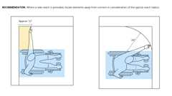
Side Reach Limitations
11B-308.3.1 Unobstructed
Where a clear floor or ground space allows a parallel approach to an element and the side reach is unobstructed, the high side reach shall be 48 inches (1219 mm) maximum and the low side reach shall be 15 inches (381 mm) minimum above the finish floor or ground.
Exceptions:
- An obstruction shall be permitted between the clear floor or ground space and the element where the depth of the obstruction is 10 inches (254 mm) maximum.
- Operable parts of fuel dispensers shall be permitted to be 54 inches (1372 mm) maximum measured from the surface of the vehicular way where fuel dispensers are installed on existing curbs.
FIGURE 11B-308.3.1—
UNOBSTRUCTED SIDE REACH
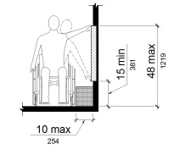
11B-308.3.2 Obstructed High Reach
Where a clear floor or ground space allows a parallel approach to an element and the high side reach is over an obstruction, the height of the obstruction shall be 34 inches (864 mm) maximum and the depth of the obstruction shall be 24 inches (610 mm) maximum. The high side reach shall be 48 inches (1219 mm) maximum for a reach depth of 10 inches (254 mm) maximum. Where the reach depth exceeds 10 inches (254 mm), the high side reach shall be 46 inches (1168 mm) maximum for a reach depth of 24 inches (610 mm) maximum.
Exceptions:
- The top of washing machines and clothes dryers shall be permitted to be 36 inches (914 mm) maximum above the finish floor.
- Operable parts of fuel dispensers shall be permitted to be 54 inches (1372 mm) maximum measured from the surface of the vehicular way where fuel dispensers are installed on existing curbs.
FIGURE 11B-308.3.2—
OBSTRUCTED HIGH SIDE REACH
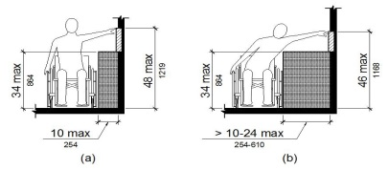
11B-308.4 Suggested Reach Ranges for Children
Where building elements such as coat hooks, lockers or operable parts are designed for use primarily by children, the suggested dimensions of Table 11B-308.4 shall be permitted. These dimensions apply to either forward or side reaches.
TABLE 11B-308.4—SUGGESTED DIMENSIONS FOR CHILDREN'S USE
SUGGESTED REACH RANGES FOR CHILDREN AGES 3 THROUGH 12
Forward or Side Reach | Ages 3 and 4 | Ages 5 through 8 | Ages 9 through 12
High  (maximum) | 36 inches  (914 mm) | 40 inches  (1016 mm) | 44 inches  (1118 mm)
Low  (minimum) | 20 inches  (508 mm) | 18 inches  (457 mm) | 16 inches  (406 mm)
Section 11B-309 Operable Parts
Diagram
UpCodes Diagrams (4)
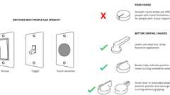
Accessible Switch & Control Recommendations (FHA)
Accessible Windows (CA 11B)
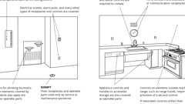
Accessible Operable Parts
Accessible Windows: Operable Parts
11B-309.1 General
Operable parts shall comply with Section 11B-309.
11B-309.2 Clear Floor Space
A clear floor or ground space complying with Section 11B-305 shall be provided.
11B-309.3 Height
Diagram
Operable parts shall be placed within one or more of the reach ranges specified in Section 11B-308.
UpCodes Diagram (1)
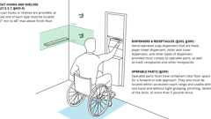
Mounting Heights: Bathroom Accessories
11B-309.4 Operation
Diagram
Operable parts shall be operable with one hand and shall not require tight grasping, pinching or twisting of the wrist. The force required to activate operable parts shall be 5 pounds (22.2 N) maximum.
Exception: Gas pump nozzles and electric vehicle connectors shall not be required to provide operable parts that have an activating force of 5 pounds (22.2 N) maximum.
UpCodes Diagrams (2)
Accessible Switch & Control Recommendations (FHA)
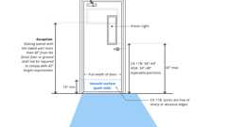
Door Hardware Req. (CA 11B)
Building product (1)
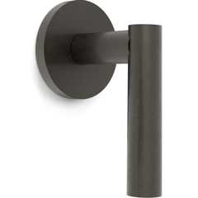
Loft Wall Mounted Trim
Watermark Designs

Division 4 Accessible Routes
Section 11B-401 General
11B-401.1 Scope
The provisions of Division 4 shall apply where required by Division 2 or where referenced by a requirement in this chapter .
Section 11B-402 Accessible Routes
Diagram
UpCodes Diagram (1)
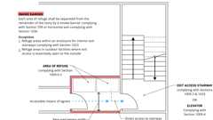
Area of Refuge Access to Stairway or Elevator
11B-402.1 General
Diagram
Accessible routes shall comply with 11B-402.
UpCodes Diagrams (2)
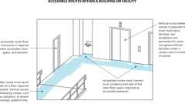
Routes Within a Facility (ADA)
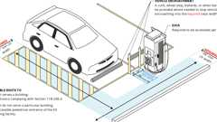
EV Charging Stations Relationship to Accessible Routes (CA 11B)
11B-402.2 Components
Diagram
Accessible routes shall consist of one or more of the following components: walking surfaces with a running slope not steeper than 1:20, doorways, ramps, curb ramps excluding the flared sides, elevators and platform lifts. All components of an accessible route shall comply with the applicable requirements of Division 4.
UpCodes Diagrams (2)
Primary
Accessible Route Components
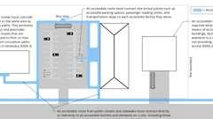
Routes Within the Site
Section 11B-403 Walking Surfaces
11B-403.1 General
Walking surfaces that are a part of an accessible route shall comply with Section 11B-403.
11B-403.2 Floor or Ground Surface
Diagram
Floor or ground surfaces shall comply with Section 11B-302.
UpCodes Diagram (1)
Slip-Resistant Surfaces
Building products (4)
Back Up Pavers 4 x 2¼ x 7⅝
Interstate Brick

Modular Paver 4 x 2¼ x 7⅝
Interstate Brick

Modular Solid 4 x 2¼ x 8
Interstate Brick

True Paver 4 x 2¼ x 8
Interstate Brick

11B-403.3 Slope
Diagram
The running slope of walking surfaces shall not be steeper than 1:20. The cross slope of walking surfaces shall not be steeper than 1:48.
Exception: The running slope of sidewalks shall not exceed the general grade established for the adjacent street or highway.
UpCodes Diagram (1)
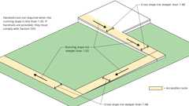Primary
Walking Surface Slopes
11B-403.4 Changes in Level
Changes in level shall comply with Section 11B-303.
11B-403.5 Clearances
Walking surfaces shall provide clearances complying with Section 11B-403.5.
Exception: Within employee work areas, clearances on common use circulation paths shall be permitted to be decreased by work area equipment provided that the decrease is essential to the function of the work being performed.
11B-403.5.1 Clear Width
Diagram
Except as provided in Sections 11B-403.5.2 and 11B-403.5.3, the clear width of walking surfaces shall be 36 inches (914 mm) minimum.
Exceptions:
- The clear width shall be permitted to be reduced to 32 inches (813 mm) minimum for a length of 24 inches (610 mm) maximum provided that reduced width segments are separated by segments that are 48 inches (1219 mm) long minimum and 36 inches (914 mm) wide minimum.
- The clear width for walking surfaces in corridors serving an occupant load of 10 or more shall be 44 inches (1118 mm) minimum.
- The clear width for sidewalks and walks shall be 48 inches (1219 mm) minimum. When, because of right-of-way restrictions, natural barriers or other existing conditions, the enforcing agency determines that compliance with the 48-inch (1219 mm) clear sidewalk width would create an unreasonable hardship, the clear width may be reduced to 36 inches (914 mm).
- The clear width for aisles shall be 36 inches (914 mm) minimum if serving elements on only one side, and 44 inches (1118 mm) minimum if serving elements on both sides.
- The clear width for accessible routes to accessible toilet compartments shall be 44 inches (1118 mm) except for door-opening widths and door swings.
FIGURE 11B-403.5.1—
CLEAR WIDTH OF AN ACCESSIBLE ROUTE
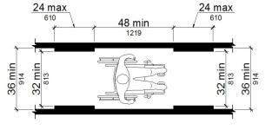
UpCodes Diagrams (3)
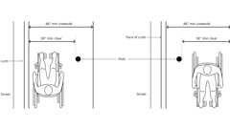Primary
Sidewalk Obstructions
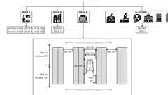
Aisle Req. by Occ. Group
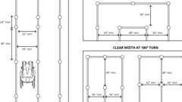
Waiting Lines as Accessible Routes
11B-403.5.2 Clear Width at Turn
Diagram
Where the accessible route makes a 180 degree turn around an element which is less than 48 inches (1219 mm) wide, clear width shall be 42 inches (1067 mm) minimum approaching the turn, 48 inches (1219 mm) minimum at the turn and 42 inches (1067 mm) minimum leaving the turn.
Exception: Where the clear width at the turn is 60 inches (1524 mm) minimum compliance with Section 11B-403.5.2 shall not be required.
FIGURE 11B-403.5.2—
CLEAR WIDTH AT TURN
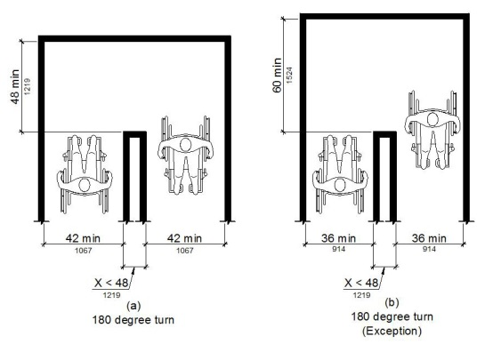
UpCodes Diagram (1)
Waiting Lines as Accessible Routes
11B-403.5.3 Passing Spaces
An accessible route with a clear width less than 60 inches (1524 mm) shall provide passing spaces at intervals of 200 feet (60,960 mm) maximum. Passing spaces shall be either: a space 60 inches (1524 mm) minimum by 60 inches (1524 mm) minimum; or, an intersection of two walking surfaces providing a T-shaped space complying with Section 11B-304.3.2 where the base and arms of the T-shaped space extend 48 inches (1219 mm) minimum beyond the intersection.
11B-403.6 Handrails
Where handrails are provided along walking surfaces with running slopes not steeper than 1:20 they shall comply with Section 11B-505.
11B-403.7 Continuous Gradient
All walks with continuous gradients shall have resting areas, 60 inches (1524 mm) in length, at intervals of 400 feet (121,920 mm) maximum. The resting area shall be at least as wide as the walk. The slope of the resting area in all directions shall be 1:48 maximum.
Section 11B-404 Doors, Doorways and Gates
Diagram
UpCodes Diagram (1)
Surfaces and Thresholds at Doors
11B-404.1 General
Doors, doorways and gates that are part of an accessible route shall comply with Section 11B-404.
Exceptions:
- Doors, doorways and gates designed to be operated only by security personnel shall not be required to comply with Sections 11B-404.2.7, 11B-404.2.8, 11B-404.2.9, 11B-404.3.2 and 11B-404.3.4 through 11B-404.3.7. A sign visible from the approach side complying with Section 11B-703.5 shall be posted stating "Entry restricted and controlled by security personnel".
- At detention and correctional facilities, doors, doorways and gates designed to be operated only by security personnel shall not be required to comply with Sections 11B-404.2.7, 11B-404.2.8, 11B-404.2.9, 11B-404.3.2 and 11B-404.3.4 through 11B-404.3.7.
11B-404.2 Manual Doors, Doorways and Manual Gates
Diagram
Manual doors and doorways and manual gates intended for user passage shall comply with Section 11B-404.2.
UpCodes Diagrams (6)
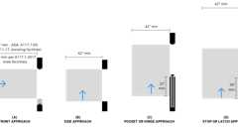
Maneuvering Clearances: Sliding, Folding Doors
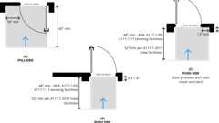
Recessed Doors and Gates
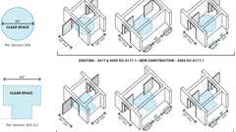
Doors in Series: Accessibility
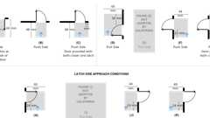
Maneuvering Clearances: Doors (CA 11B)
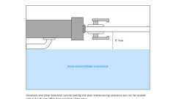
Handrails at Req. Door Clearances
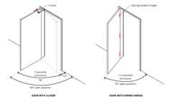
Door and Gate Closing Speed
11B-404.2.1 Revolving Doors, Gates and Turnstiles
Revolving doors, revolving gates and turnstiles shall not be part of an accessible route.
11B-404.2.2 Double-Leaf Doors and Gates
At least one of the active leaves of doorways with two leaves shall comply with Sections 11B-404.2.3 and 11B-404.2.4.
11B-404.2.3 Clear Width
Diagram
Door openings shall provide a clear width of 32 inches (813 mm) minimum. Clear openings of doorways with swinging doors shall be measured between the face of the door and the stop, with the door open 90 degrees. Openings more than 24 inches (610 mm) deep shall provide a clear opening of 36 inches (914 mm) minimum. There shall be no projections into the required clear opening width lower than 34 inches (864 mm) above the finish floor or ground. Projections into the clear opening width between 34 inches (864 mm) and 80 inches (2032 mm) above the finish floor or ground shall not exceed 4 inches (102 mm).
Exceptions:
- In alterations, a projection of ⁵/₈ inch (15.9 mm) maximum into the required clear width shall be permitted for the latch side stop.
- Door closers and door stops shall be permitted to be 78 inches (1981 mm) minimum above the finish floor or ground.
FIGURE 11B-404.2.3—
CLEAR WIDTH OF DOORWAYS
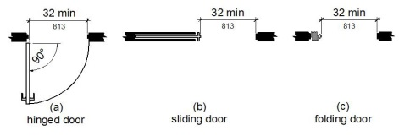
UpCodes Diagrams (2)
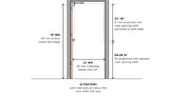
Clear Width & Vertical Clearance of Doors & Gates
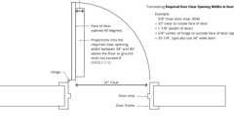
Doors: Min. Required Clear Opening Width
11B-404.2.4 Maneuvering Clearances
Diagram
Minimum maneuvering clearances at doors and gates shall comply with Section 11B-404.2.4. Maneuvering clearances shall extend the full width of the doorway and the required latch side or hinge side clearance.
Exception: Reserved.
UpCodes Diagrams (2)
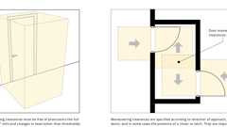Primary
Door Maneuvering Clearances
Primary
Maneuvering Clearances: Doors (CA 11B)
11B-404.2.4.1 Swinging Doors and Gates
Swinging doors and gates shall have maneuvering clearances complying with Table 11B-404.2.4.1.
TABLE 11B-404.2.4.1—
MANEUVERING CLEARANCES AT MANUAL SWINGING DOORS AND GATES
TYPE OF USE |  | MINIMUM MANEUVERING CLEARANCE
Approach direction | Door or gate side | Perpendicular to doorway | Parallel to doorway  (beyond latch side unless noted)
From front | Pull | 60 inches (1524 mm) | 18 inches (457 mm)⁵
From front | Push | 48 inches (1219 mm) | 0 inches (0 mm)¹
From hinge side | Pull | 60 inches (1524 mm) | 36 inches (914 mm)
From hinge side | Push | 44 inches (1118 mm)² | 22 inches (559 mm)³
From latch side | Pull | 60 inches (1524 mm) | 24 inches (610 mm)
From latch side | Push | 44 inches (1118 mm)⁴ | 24 inches (610 mm)
- Add 12 inches (305 mm) if closer and latch are provided.
- Add 4 inches (102 mm) if closer and latch are provided.
- Beyond hinge side.
- Add 4 inches (102 mm) if closer is provided.
- Add 6 inches (152 mm) at exterior side of exterior doors.
FIGURE 11B-404.2.4.1—
MANEUVERING CLEARANCES AT MANUAL SWINGING DOORS AND GATES
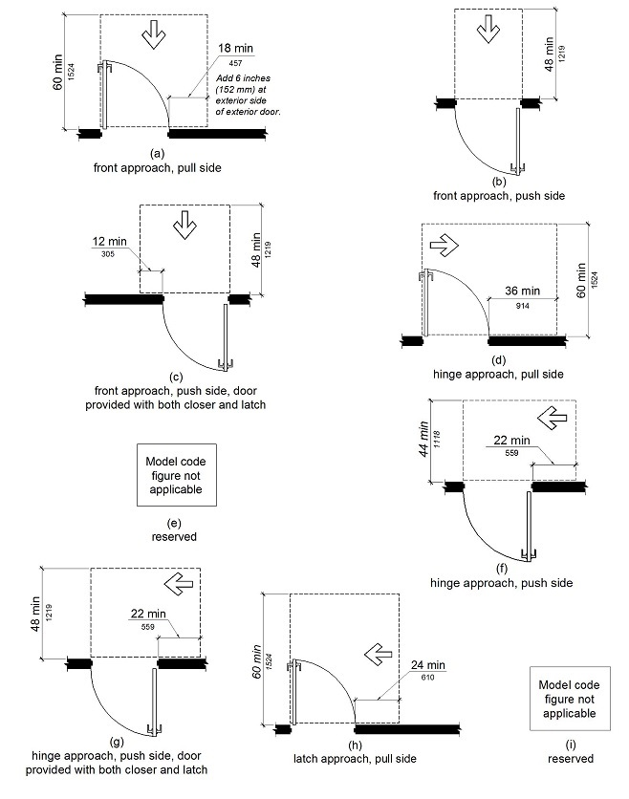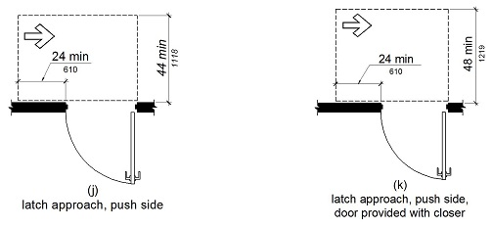
11B-404.2.4.2 Doorways Without Doors or Gates, Sliding Doors and Folding Doors
Diagram
Doorways less than 36 inches (914 mm) wide without doors or gates, sliding doors or folding doors shall have maneuvering clearances complying with Table 11B-404.2.4.2.
TABLE 11B-404.2.4.2—
MANEUVERING CLEARANCES AT DOORWAYS WITHOUT DOORS OR GATES, MANUAL SLIDING DOORS and MANUAL FOLDING DOORS
 | MINIMUM MANEUVERING CLEARANCE
Approach direction | Perpendicular to doorway | Parallel to doorway (beyond stop/latch side unless noted)
From front | 48 inches (1219 mm) | 0 inches (0 mm)
From side¹ | 42 inches (1067 mm) | 0 inches (0 mm)
From pocket/hinge side | 42 inches (1067 mm) | 22 inches (559 mm)²
From stop/latch side | 42 inches (1067 mm) | 24 inches (610 mm)
- Doorway with no door only.
- Beyond pocket/hinge side.
FIGURE 11B-404.2.4.2—
MANEUVERING CLEARANCES AT DOORWAYS WITHOUT DOORS, SLIDING DOORS, GATES and FOLDING DOORS
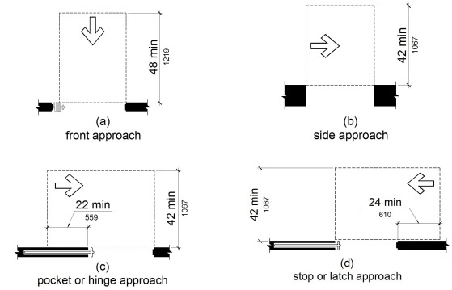
UpCodes Diagram (1)
Primary
Maneuvering Clearances: Sliding, Folding Doors
11B-404.2.4.3 Recessed Doors and Gates
Diagram
Maneuvering clearances for forward approach shall be provided when any obstruction within 18 inches (457 mm) of the latch side at an interior doorway, or within 24 inches (610 mm) of the latch side of an exterior doorway, projects more than 8 inches (203 mm) beyond the face of the door, measured perpendicular to the face of the door or gate.
FIGURE 11B-404.2.4.3—
MANEUVERING CLEARANCES AT RECESSED DOORS AND GATES
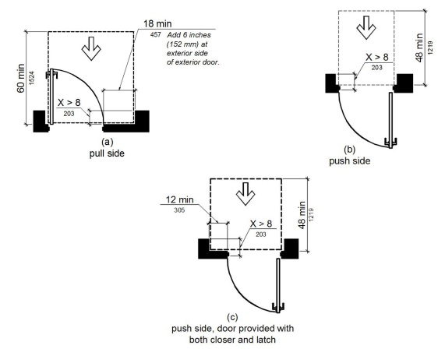
UpCodes Diagrams (2)
Primary
Recessed Doors and Gates
Handrails at Req. Door Clearances
11B-404.2.4.4 Floor or Ground Surface
Diagram
Floor or ground surface within required maneuvering clearances shall comply with Section 11B-302. Changes in level, slopes exceeding 1:48, and detectable warnings shall not be permitted.
Exceptions:
- Reserved.
- Changes in level at thresholds complying with Section 11B-404.2.5 shall be permitted.
UpCodes Diagram (1)
Primary
Surfaces and Thresholds at Doors
11B-404.2.5 Thresholds
Diagram
Thresholds, if provided at doorways, shall be ¹/₂ inch (12.7 mm) high maximum. Raised thresholds and changes in level at doorways shall comply with Sections 11B-302 and 11B-303.
Exception: Reserved.
UpCodes Diagram (1)
Primary
Surfaces and Thresholds at Doors
11B-404.2.6 Doors in Series and Gates in Series
Diagram
The distance between two hinged or pivoted doors in series and gates in series shall be 48 inches (1219 mm) minimum plus the width of doors or gates swinging into the space.
FIGURE 11B-404.2.6—
DOORS IN SERIES AND GATES IN SERIES
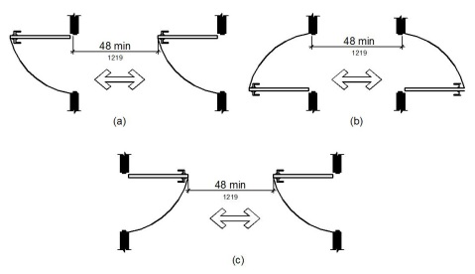
UpCodes Diagram (1)
Doors in Series: Accessibility
11B-404.2.7 Door and Gate Hardware
Diagram
Handles, pulls, latches, locks and other operable parts on doors and gates shall comply with Section 11B-309.4. Operable parts of such hardware shall be 34 inches (864 mm) minimum and 44 inches (1118 mm) maximum above the finish floor or ground. Where sliding doors are in the fully open position, operating hardware shall be exposed and usable from both sides.
Exceptions:
- Existing locks shall be permitted in any location at existing glazed doors without stiles, existing overhead rolling doors or grilles and similar existing doors or grilles that are designed with locks that are activated only at the top or bottom rail.
- Access gates in barrier walls and fences protecting pools, spas and hot tubs shall be permitted to have operable parts of the release of latch on self-latching devices at 54 inches (1372 mm) maximum above the finish floor or ground provided the self-latching devices are not also self-locking devices and operated by means of a key, electronic opener or integral combination lock.
UpCodes Diagram (1)
Primary
Door Hardware Req. (CA 11B)
11B-404.2.8 Closing Speed
Diagram
Door and gate closing speed shall comply with Section 11B-404.2.8.
UpCodes Diagram (1)
Primary
Door and Gate Closing Speed
11B-404.2.8.1 Door Closers and Gate Closers
Door closers and gate closers shall be adjusted so that from an open position of 90 degrees, the time required to move the door to a position of 12 degrees from the latch is 5 seconds minimum.
11B-404.2.8.2 Spring Hinges
Door and gate spring hinges shall be adjusted so that from the open position of 70 degrees, the door or gate shall move to the closed position in 1.5 seconds minimum.
11B-404.2.9 Door and Gate Opening Force
The force for pushing or pulling open a door or gate shall be as follows:
- Interior hinged doors and gates: 5 pounds (22.2 N) maximum.
- Sliding or folding doors: 5 pounds (22.2 N) maximum.
- Required fire doors: the minimum opening force allowable by the appropriate administrative authority, not to exceed 15 pounds (66.7 N).
- Exterior hinged doors: 5 pounds (22.2 N) maximum.
These forces do not apply to the force required to retract latch bolts or disengage other devices that hold the door or gate in a closed position.
Exception: When, at a single location, one of every eight exterior door leafs, or fraction of eight, is a powered door, other exterior doors at the same location, serving the same interior space, may have a maximum opening force of 8.5 pounds (37.8 N). The powered leaf(s) shall be located closest to the accessible route.
- Powered doors shall comply with Section 11B-404.3. Powered doors shall be fully automatic doors complying with Builders Hardware Manufacturers' Association (BHMA) A156.10 or low energy operated doors complying with BHMA A156.19.
- Powered doors serving a building or facility with an occupancy of 150 or more shall be provided with a back-up battery or back-up generator. The back-up power source shall be able to cycle the door a minimum of 100 cycles.
- Powered doors shall be controlled on both the interior and exterior sides of the doors by sensing devices, push plates, vertical actuation bars or other similar operating devices complying with Section 11B-309.
  - At each location where push plates are provided there shall be two push plates; the centerline of one push plate shall be 7 inches (178 mm) minimum and 8 inches (203 mm) maximum above the floor or ground surface and the centerline of the second push plate shall be 30 inches (762 mm) minimum and 44 inches (1118 mm) maximum above the floor or ground surface. Each push plate shall be a minimum of 4 inches (102 mm) diameter or a minimum of 4 inches by 4 inches (102 mm by 102 mm) square and shall display the International Symbol of Accessibility complying with Section 11B-703.7.
  - At each location where vertical actuation bars are provided the operable portion shall be located so the bottom is 5 inches (127 mm) maximum above the floor or ground surface and the top is 35 inches (889 mm) minimum above the floor or ground surface. The operable portion of each vertical actuation bar shall be a minimum of 2 inches (51 mm) wide and shall display the International Symbol of Accessibility complying with Section 11B-703.7.
  - Where push plates, vertical actuation bars or other similar operating devices are provided, they shall be placed in a conspicuous location. A level and clear floor or ground space for forward or parallel approach complying with Section 11B-305 shall be provided, centered on the operating device. Doors shall not swing into the required clear floor or ground space.
- Signs identifying the accessible entrance required by Section 11B-216.6 shall be placed on, or immediately adjacent to, each powered door. Signs shall be provided in compliance with BHMA A156.10 or BHMA A156.19, as applicable.
- In addition to the requirements of Item d, where a powered door is provided in buildings or facilities containing assembly occupancies of 300 or more, a sign displaying the International Symbol of Accessibility measuring 6 inches by 6 inches (152 mm by 152 mm), complying with Section 11B-703.7, shall be provided above the door on both the interior and exterior sides of each powered door.
11B-404.2.10 Door and Gate Surfaces
Diagram
Swinging door and gate surfaces within 10 inches (254 mm) of the finish floor or ground measured vertically shall have a smooth surface on the push side extending the full width of the door or gate. Parts creating horizontal or vertical joints in these surfaces shall be within ¹/₁₆ inch (1.6 mm) of the same plane as the other and be free of sharp or abrasive edges. Cavities created by added kick plates shall be capped.
Exceptions:
- Sliding doors shall not be required to comply with Section 11B-404.2.10.
- Tempered glass doors without stiles and having a bottom rail or shoe with the top leading edge tapered at 60 degrees minimum from the horizontal shall not be required to meet the 10 inch (254 mm) bottom smooth surface height requirement.
- Doors and gates that do not extend to within 10 inches (254 mm) of the finish floor or ground shall not be required to comply with Section 11B-404.2.10.
- Reserved.
UpCodes Diagrams (2)
Primary
Door Hardware Req. (CA 11B)
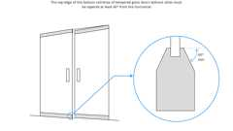
Door Surface Excpt. - Tempered Glass Door
11B-404.2.11 Vision Lights
Diagram
Doors, gates and side lights adjacent to doors or gates, containing one or more glazing panels that permit viewing through the panels shall have the bottom of at least one glazed panel located 43 inches (1092 mm) maximum above the finish floor.
Exception: Glazing panels with the lowest part more than 66 inches (1676 mm) from the finish floor or ground shall not be required to comply with Section 11B-404.2.11.
UpCodes Diagram (1)
Primary
Door Hardware Req. (CA 11B)
Building product (1)
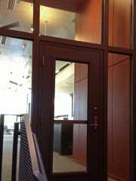
GPX® Vision Kit
SaftiFirst

11B-404.3 Automatic and Power-Assisted Doors and Gates
Diagram
Automatic doors and automatic gates shall comply with Section 11B-404.3. Full-powered automatic doors shall comply with ANSI/BHMA A156.10. Low-energy and power-assisted doors shall comply with ANSI/BHMA A156.19.
UpCodes Diagram (1)
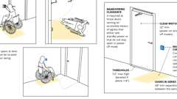
Automated Doors: Low Energy
11B-404.3.1 Clear Width
Doorways shall provide a clear opening of 32 inches (813 mm) minimum in power-on and power-off mode. The minimum clear width for automatic door systems in a doorway shall provide a clear, unobstructed opening of 32 inches (813 mm) with one leaf positioned at an angle of 90 degrees from its closed position.
11B-404.3.2 Maneuvering Clearance
Clearances at power-assisted doors and gates shall comply with Section 11B-404.2.4. Clearances at automatic doors and gates without standby power and serving an accessible means of egress shall comply with Section 11B-404.2.4.
Exception: Where automatic doors and gates remain open in the power-off condition, compliance with Section 11B-404.2.4 shall not be required.
11B-404.3.3 Thresholds
Thresholds and changes in level at doorways shall comply with Section 11B-404.2.5.
11B-404.3.4 Doors in Series and Gates in Series
Doors in series and gates in series shall comply with Section 11B-404.2.6.
11B-404.3.5 Controls
Manually operated controls shall comply with Section 11B-309. The clear floor space adjacent to the control shall be located beyond the arc of the door swing.
11B-404.3.6 Break Out Opening
Where doors and gates without standby power are a part of a means of egress, the clear break out opening at swinging or sliding doors and gates shall be 32 inches (813 mm) minimum when operated in emergency mode.
Exception: Where manual swinging doors and gates comply with Section 11B-404.2 and serve the same means of egress compliance with Section 11B-404.3.6 shall not be required.
11B-404.3.7 Revolving Doors, Revolving Gates and Turnstiles
Revolving doors, revolving gates and turnstiles shall not be part of an accessible route.
Section 11B-405 Ramps
11B-405.1 General
Diagram
Ramps on accessible routes shall comply with Section 11B-405.
Exception: In assembly areas, aisle ramps adjacent to seating and not serving elements required to be on an accessible route shall not be required to comply with Section 11B-405.
UpCodes Diagram (1)
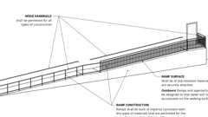
Ramp Construction
11B-405.2 Slope
Ramp runs shall have a running slope not steeper than 1:12.
Exception: Reserved.
11B-405.3 Cross Slope
Cross slope of ramp runs shall not be steeper than 1:48.
11B-405.4 Floor or Ground Surfaces
Floor or ground surfaces of ramp runs shall comply with Section 11B-302. Changes in level other than the running slope and cross slope are not permitted on ramp runs.
11B-405.5 Clear Width
Diagram
The clear width of a ramp run shall be 48 inches (1219 mm) minimum.
Exceptions:
- Within employee work areas, the required clear width of ramps that are a part of common use circulation paths shall be permitted to be decreased by work area equipment provided that the decrease is essential to the function of the work being performed.
- Handrails may project into the required clear width of the ramp at each side 3¹/₂ inches (89 mm) maximum at the handrail height.
- The clear width of ramps in residential uses serving an occupant load of fifty or less shall be 36 inches (914 mm) minimum between handrails.
UpCodes Diagram (1)
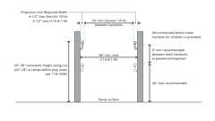Primary
Ramp Handrail Height and Clearance (CA)
11B-405.6 Rise
The rise for any ramp run shall be 30 inches (762 mm) maximum.
11B-405.7 Landings
Ramps shall have landings at the top and the bottom of each ramp run. Landings shall comply with Section 11B-405.7.
FIGURE 11B-405.7—
RAMP LANDINGS
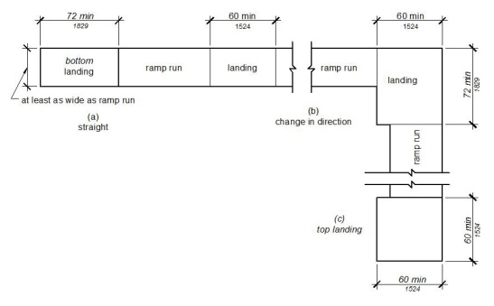
11B-405.7.1 Slope
Landings shall comply with Section 11B-302. Changes in level, slopes exceeding 1:48, and detectable warnings shall not be permitted.
Exception: Reserved.
11B-405.7.2 Width
The landing clear width shall be at least as wide as the widest ramp run leading to the landing.
11B-405.7.2.1
Top landings shall be 60 inches (1524 mm) wide minimum.
11B-405.7.3 Length
The landing clear length shall be 60 inches (1524 mm) long minimum.
11B-405.7.3.1
Bottom landings shall extend 72 inches (1829 mm) minimum in the direction of ramp run.
11B-405.7.4 Change in Direction
Ramps that change direction between runs at landings shall have a clear landing 60 inches (1525 mm) minimum by 72 inches (1829 mm) minimum in the direction of downward travel from the upper ramp run.
11B-405.7.5 Doorways
Where doorways are located adjacent to a ramp landing, maneuvering clearances required by Sections 11B-404.2.4 and 11B-404.3.2 shall be permitted to overlap the required landing area. Doors, when fully open, shall not reduce the required ramp landing width by more than 3 inches (76 mm). Doors, in any position, shall not reduce the minimum dimension of the ramp landing to less than 42 inches (1067 mm).
11B-405.8 Handrails
Diagram
Ramp runs shall have handrails complying with Section 11B-505.
Exceptions:
- Reserved.
- Reserved.
- Curb ramps do not require handrails.
- At door landings, handrails are not required on ramp runs less than 6 inches (152 mm) in rise or 72 inches (1829 mm) in length.
UpCodes Diagrams (2)
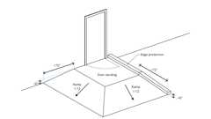Primary
Ramp Handrail Exception (CBC 11B)
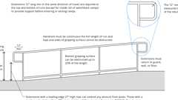
Ramp Handrail Heights and Clearances
11B-405.9 Edge Protection
Diagram
Edge protection complying with Section 11B-405.9.2 shall be provided on each side of ramp runs and at each side of ramp landings.
Exceptions:
- Edge protection shall not be required on ramps that are not required to have handrails and have sides complying with Section 11B-406.2.2.
- Edge protection shall not be required on the sides of ramp landings serving an adjoining ramp run or stairway.
- Edge protection shall not be required on the sides of ramp landings having a vertical drop-off of ¹/₂ inch (12.7 mm) maximum within 10 inches (254 mm) horizontally of the minimum landing area specified in Section 11B-405.7.
UpCodes Diagram (1)
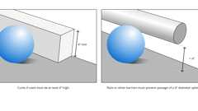Primary
Ramp Edge Protection (CBC 11B)
11B-405.9.1 Reserved
11B-405.9.2 Curb or Barrier
Diagram
A curb or barrier shall be provided that prevents the passage of a 4-inch (102 mm) diameter sphere, where any portion of the sphere is within 4 inches (102 mm) of the finish floor or ground surface. To prevent wheel entrapment, the curb or barrier shall provide a continuous and uninterrupted barrier along the length of the ramp.
FIGURE 11B-405.9.2—
CURB OR BARRIER EDGE PROTECTION
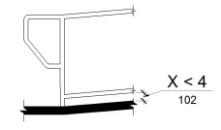
UpCodes Diagram (1)
Ramp Edge Protection (CBC 11B)
11B-405.10 Wet Conditions
Landings subject to wet conditions shall be designed to prevent the accumulation of water.
Section 11B-406 Curb Ramps, Blended Transitions and Islands
11B-406.1 General
Curb ramps, blended transitions and islands on accessible routes shall comply with Section 11B-406. Curb ramps may be perpendicular, parallel, or a combination of perpendicular and parallel.
11B-406.1.1 Perpendicular Curb Ramps
Perpendicular curb ramps shall comply with Section 11B-406.2.
11B-406.1.2 Parallel Curb Ramps
Parallel curb ramps shall comply with Section 11B-406.3.
11B-406.1.3 Blended Transitions
Blended transitions shall comply with Section 11B-406.4.
11B-406.1.4 Islands
Islands shall comply with Section 11B-406.6.
11B-406.2 Perpendicular Curb Ramps
Perpendicular curb ramps shall comply with Sections 11B-406.2 and 11B-406.5.
11B-406.2.1 Slope
Ramp runs shall have a running slope not steeper than 1:12.
11B-406.2.2 Sides of Curb Ramps
Where provided, curb ramp flares shall not be steeper than 1:10.
FIGURE 11B-406.2.2—
SIDES OF CURB RAMPS
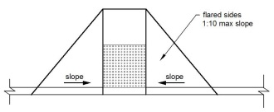
11B-406.3 Parallel Curb Ramps
Parallel curb ramps shall comply with Sections 11B-406.3 and 11B-406.5. A parallel curb ramp may be provided with one sloping segment or two opposing sloping segments.
11B-406.3.1 Slope
The running slope of the curb ramp segments shall be in-line with the direction of sidewalk travel. Ramp runs shall have a running slope not steeper than 1:12.
11B-406.3.2 Turning Space
A turning space 48 inches (1219 mm) minimum by 48 inches (1219 mm) minimum shall be provided at the bottom of the curb ramp. The slope of the turning space in all directions shall be 1:48 maximum.
FIGURE 11B-406.3.2—
PARALLEL CURB RAMPS
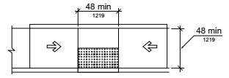
11B-406.4 Blended Transitions
Diagram
Blended transitions shall comply with Sections 11B-406.4 and 11B-406.5.
UpCodes Diagram (1)
Blended Transitions
11B-406.4.1 Slope
Blended transitions shall have a running slope not steeper than 1:20.
11B-406.5 Common Requirements
Curb ramps and blended transitions shall comply with Section 11B-406.5.
11B-406.5.1 Location
Curb ramps and the flared sides of curb ramps shall be located so that they do not project into vehicular traffic lanes, parking spaces or parking access aisles. Curb ramps at marked crossings shall be wholly contained within the markings, excluding any flared sides.
Exception: Diagonal curb ramps shall comply with Section 11B-406.5.9.
11B-406.5.2 Width
The clear width of curb ramp runs (excluding any flared sides), blended transitions, and turning spaces shall be 48 inches (1219 mm) minimum.
11B-406.5.3 Landings
Landings shall be provided at the tops of curb ramps and blended transitions. The landing clear length shall be 48 inches (1219 mm) minimum. The landing clear width shall be at least as wide as the curb ramp, excluding any flared sides, or the blended transition leading to the landing. The slope of the landing in all directions shall be 1:48 maximum.
Exception: Parallel curb ramps shall not be required to comply with Section 11B-406.5.3.
FIGURE 11B-406.5.3—
LANDINGS AT THE TOP OF CURB RAMPS
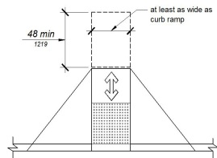
11B-406.5.4 Floor or Ground Surfaces
Floor or ground surfaces of curb ramps and blended transitions shall comply with Section 11B-405.4.
11B-406.5.5 Wet Conditions
Curb ramps and blended transitions shall comply with Section 11B-405.10.
11B-406.5.6 Grade Breaks
Grade breaks at the top and bottom of curb ramp runs shall be perpendicular to the direction of the ramp run. Grade breaks shall not be permitted on the surface of ramp runs and turning spaces. Surface slopes that meet at grade breaks shall be flush.
11B-406.5.7 Cross Slope
The cross slope of curb ramps and blended transitions shall be 1:48 maximum.
11B-406.5.8 Counter Slope
Counter slopes of adjoining gutters and road surfaces immediately adjacent to and within 24 inches (610 mm) of the curb ramp shall not be steeper than 1:20. The adjacent surfaces at transitions at curb ramps to walks, gutters and streets shall be at the same level.
FIGURE 11B-406.5.8—
COUNTER SLOPE OF SURFACES ADJACENT TO CURB RAMPS
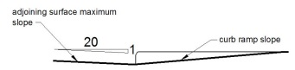
11B-406.5.9 Clear Space at Diagonal Curb Ramps
The bottom of diagonal curb ramps shall have a clear space 48 inches (1219 mm) minimum outside active traffic lanes of the roadway. Diagonal curb ramps provided at marked crossings shall provide the 48 inches (1219 mm) minimum clear space within the markings.
11B-406.5.10 Diagonal Curb Ramps
Diagonal or corner type curb ramps are perpendicular or parallel curb ramps that are oriented diagonally at an intersection. Diagonal or corner type curb ramps with returned curbs or other well-defined edges shall have the edges parallel to the direction of pedestrian flow. Diagonal curb ramps with flared sides shall have a segment of curb 24 inches (610 mm) long minimum located on each side of the curb ramp and within the marked crossing.
FIGURE 11B-406.5.10—
DIAGONAL OR CORNER TYPE CURB RAMPS
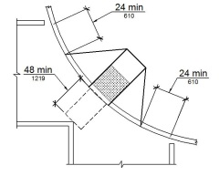
11B-406.5.11 Reserved
11B-406.5.12 Detectable Warnings
Curb ramps and blended transitions shall have detectable warnings complying with Section 11B-705.
11B-406.6 Islands
Raised islands in crossings shall be cut through level with the street or have curb ramps at both sides. The clear width of the accessible route at islands shall be 60 inches (1524 mm) wide minimum. Where curb ramps are provided, they shall comply with Section 11B-406. Landings complying with Section 11B-406.5.3 and the accessible route shall be permitted to overlap. Islands shall have detectable warnings complying with Section 11B-705.
FIGURE 11B-406.6—
ISLANDS IN CROSSINGS
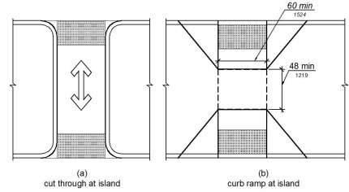
Section 11B-407 Elevators
Diagram
UpCodes Diagram (1)
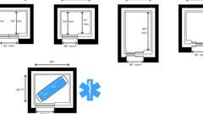
Elevator Car Dimensions
11B-407.1 General
Elevators shall comply with Section 11B-407 and with ASME A17.1 They shall be passenger elevators as classified by ASME A17.1. Elevator operation shall be automatic.
11B-407.1.1 Combined Passenger and Freight Elevators
When the only elevators provided for use by the public and employees are combination passenger and freight elevators, they shall comply with Section 11B-407 and with ASME A17.1.
11B-407.2 Elevator Landing Requirements
Elevator landings shall comply with Section 11B-407.2.
11B-407.2.1 Call Controls
Where elevator call buttons or keypads are provided, they shall comply with Sections 11B-407.2.1 and 11B-309.4.
Exception: Reserved.
11B-407.2.1.1 Height
Call buttons and keypads shall be located within one of the reach ranges specified in Section 11B-308, measured to the centerline of the highest operable part.
Exception: Reserved.
11B-407.2.1.2 Size and Shape
Call buttons shall have square shoulders, be ³/₄ inch (19.1 mm) minimum in the smallest dimension and shall be raised ¹/₈ inch (3.2 mm) plus or minus ¹/₃₂ inch (0.8 mm) above the surrounding surface. The buttons shall be activated by a mechanical motion that is detectable.
Exception: Reserved.
11B-407.2.1.3 Clear Floor or Ground Space
A clear floor or ground space complying with Section 11B-305 shall be provided at call controls.
11B-407.2.1.4 Location
The call button that designates the up direction shall be located above the call button that designates the down direction.
Exception: Reserved.
11B-407.2.1.5 Signals
Call buttons shall have visible signals that will activate when each call is registered and will extinguish when each call is answered. Call buttons shall be internally illuminated with a white light over the entire surface of the button.
Exceptions:
- Reserved.
- Reserved.
11B-407.2.1.6 Keypads
Where keypads are provided, keypads shall be in a standard telephone keypad arrangement and shall comply with Section 11B-407.4.7.2.
11B-407.2.2 Hall Signals
Hall signals, including in-car signals, shall comply with Section 11B-407.2.2.
11B-407.2.2.1 Visible and Audible Signals
A visible and audible signal shall be provided at each hoistway entrance to indicate which car is answering a call and the car's direction of travel. Where in-car signals are provided, they shall be visible from the floor area adjacent to the hall call buttons.
Exceptions:
- Reserved.
- Reserved.
11B-407.2.2.2 Visible Signals
Visible signal fixtures shall be centered at 72 inches (1829 mm) minimum above the finish floor or ground. The visible signal elements shall be a minimum 2¹/₂ inches (64 mm) high by 2¹/₂ inches (64 mm) wide. Signals shall be visible from the floor area adjacent to the hall call button.
Exceptions:
- Reserved.
- Reserved.
FIGURE 11B-407.2.2.2—
VISIBLE HALL SIGNALS
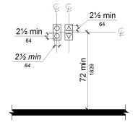
11B-407.2.2.3 Audible Signals
Audible signals shall sound once for the up direction and twice for the down direction, or shall have verbal annunciators that indicate the direction of elevator car travel. Audible signals shall have a frequency of 1500 Hz maximum. Verbal annunciators shall have a frequency of 300 Hz minimum and 3000 Hz maximum. The audible signal and verbal annunciator shall be 10 dB minimum above ambient, but shall not exceed 80 dB, measured at the hall call button.
Exceptions:
- Reserved.
- Reserved.
11B-407.2.2.4
Reserved.
11B-407.2.3 Hoistway Signs
Signs at elevator hoistways shall comply with Section 11B-407.2.3.
11B-407.2.3.1 Floor Designation
Floor designations complying with Sections 11B-703.2 and 11B-703.4.1 shall be provided on both jambs of elevator hoistway entrances. Floor designations shall be provided in both raised characters and Braille. Raised characters shall be 2 inches (51 mm) high. A raised star, placed to the left of the floor designation, shall be provided on both jambs at the main entry level. The outside diameter of the star shall be 2 inches (51 mm) and all points shall be of equal length. Raised characters, including the star, shall be white on a black background. Braille complying with Section 11B-703.3 shall be placed below the corresponding raised characters and the star. The Braille translation for the star shall be "MAIN". Applied plates are acceptable if they are permanently fixed to the jamb.
FIGURE 11B-407.2.3.1—
FLOOR DESIGNATIONS ON JAMBS OF ELEVATOR HOISTWAY ENTRANCES
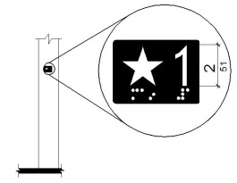
11B-407.2.3.2
Reserved.
11B-407.3 Elevator Door Requirements
Diagram
Hoistway and car doors shall comply with Section 11B-407.3.
UpCodes Diagram (1)
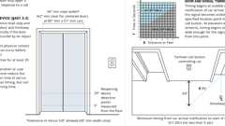
Elevator Door Req.
11B-407.3.1 Type
Elevator doors shall be the horizontal sliding type. Car gates shall be prohibited.
11B-407.3.2 Operation
Elevator hoistway and car doors shall open and close automatically.
Exception: Existing manually operated hoistway swing doors shall be permitted provided that they comply with Sections 11B-404.2.3 and 11B-404.2.9. Car door closing shall not be initiated until the hoistway door is closed.
11B-407.3.3 Reopening Device
Elevator doors shall be provided with a reopening device complying with Section 11B-407.3.3 that shall stop and reopen a car door and hoistway door automatically if the door becomes obstructed by an object or person.
Exception: Existing elevators with manually operated doors shall not be required to comply with Section 11B-407.3.3.
11B-407.3.3.1 Height
The device shall be activated by sensing an obstruction passing through the opening at 5 inches (127 mm) nominal and 29 inches (737 mm) nominal above the finish floor.
11B-407.3.3.2 Contact
The device shall not require physical contact to be activated, although contact is permitted to occur before the door reverses.
11B-407.3.3.3 Duration
Door reopening devices shall remain effective for 20 seconds minimum.
11B-407.3.4 Door and Signal Timing
The minimum acceptable time from notification that a car is answering a call until the doors of that car start to close shall be calculated from the following equation:
T = D/(1.5 ft/s) or T = D/(457 mm/s) = 5 seconds minimum where T equals the total time in seconds and D equals the distance (in feet or millimeters) from the point in the lobby or corridor 60 inches (1524 mm) directly in front of the farthest call button controlling that car to the centerline of its hoistway door.
Exceptions:
- For cars with in-car lanterns, T shall be permitted to begin when the signal is visible from the point 60 inches (1524 mm) directly in front of the farthest hall call button and the audible signal is sounded.
- Reserved.
11B-407.3.5 Door Delay
Elevator doors shall remain fully open in response to a car call for 5 seconds minimum.
11B-407.3.6 Width
The width of elevator doors shall comply with Table 11B-407.4.1.
Exception: In existing elevators, a power-operated car door complying with Section 11B-404.2.3 shall be permitted.
11B-407.4 Elevator Car Requirements
Elevator cars shall comply with Section 11B-407.4.
11B-407.4.1 Car Dimensions
Diagram
Inside dimensions of elevator cars and clear width of elevator doors shall comply with Table 11B-407.4.1.
Exception: In existing buildings, where existing shaft configuration prohibits strict compliance with Section 11B-407.4.1, existing elevator car configurations that provide a clear floor area of 18 square feet (1.67 m²) minimum and also provide an inside clear depth 54 inches (1372 mm) minimum and a clear width 48 inches (1219 mm) minimum shall be permitted.
FIGURE 11B-407.4.1—
ELEVATOR CAR DIMENSIONS
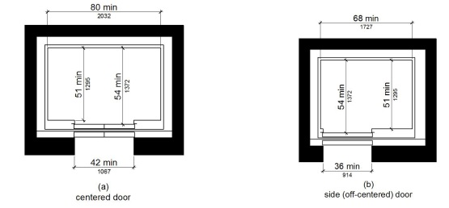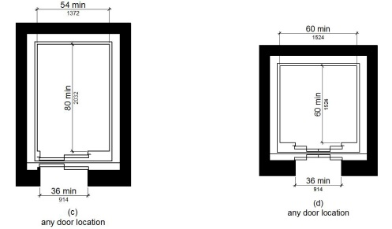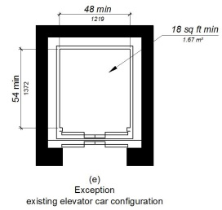
TABLE 11B-407.4.1—
ELEVATOR CAR DIMENSIONS
 | MINIMUM MANEUVERING CLEARANCE
Door location | Door clear width | Inside car, side to side | Inside car, back  wall to front return | Inside car, back  wall to inside face of door
Centered | 42 inches  (1067 mm) | 80 inches  (2032 mm) | 51 inches  (1295 mm) | 54 inches  (1372 mm)
Side (off-centered) | 36 inches  (914 mm)¹ | 68 inches  (1727 mm) | 51 inches  (1295 mm) | 54 inches  (1372 mm)
Any | 36 inches  (914 mm)¹ | 54 inches  (1372 mm) | 80 inches  (2032 mm) | 80 inches  (2032 mm)
Any | 36 inches  (914 mm)² | 60 inches  (1524 mm)² | 60 inches  (1524 mm)² | 60 inches  (1524 mm)²
- A tolerance of minus ⁵/₈ inch (15.9 mm) is permitted.
- Other car configurations that provide a turning space complying with Section 11B-304 with the door closed shall be permitted.
UpCodes Diagram (1)
Elevator Car Dimensions
11B-407.4.2 Floor Surfaces
Floor surfaces in elevator cars shall comply with Sections 11B-302 and 11B-303.
11B-407.4.3 Platform to Hoistway Clearance
The clearance between the car platform sill and the edge of any hoistway landing shall be 1¹/₄ inch (32 mm) maximum.
11B-407.4.4 Leveling
Each car shall be equipped with a self-leveling feature that will automatically bring and maintain the car at floor landings within a tolerance of ¹/₂ inch (12.7 mm) under rated loading to zero loading conditions.
11B-407.4.5 Illumination
The level of illumination at the car controls, platform, car threshold and car landing sill shall be 5 foot candles (54 lux) minimum.
11B-407.4.6 Elevator Car Controls
Where provided, elevator car controls shall comply with Sections 11B-407.4.6 and 11B-309.4.
Exception: In existing elevators, where a new car operating panel complying with Section 11B-407.4.6 is provided, existing car operating panels may remain operational and shall not be required to comply with Section 11B-407.4.6.
11B-407.4.6.1 Location
Controls shall be located within one of the reach ranges specified in Section 11B-308.
Exceptions:
- Where the elevator panel serves more than 16 openings and a parallel approach is provided, buttons with floor designations shall be permitted to be 54 inches (1372 mm) maximum above the finish floor.
- In existing elevators, car control buttons with floor designations shall be permitted to be located 54 inches (1372 mm) maximum above the finish floor where a parallel approach is provided.
11B-407.4.6.2 Buttons
Car control buttons with floor designations shall comply with Section 11B-407.4.6.2.
Exception: Reserved.
11B-407.4.6.2.1 Size and Shape
Buttons shall have square shoulders, be ³/₄ inch (19.1 mm) minimum in their smallest dimension and be raised ¹/₈ inch (3.2 mm) plus or minus ¹/₃₂ inch (0.8 mm) above the surrounding surface.
11B-407.4.6.2.2 Arrangement
Buttons shall be arranged with numbers in ascending order. When two or more columns of buttons are provided they shall read from left to right.
11B-407.4.6.2.3 Illumination
Car control buttons shall be illuminated.
11B-407.4.6.2.4 Operation
Car control buttons shall be activated by a mechanical motion that is detectable.
11B-407.4.6.3 Keypads
Car control keypads shall be in a standard telephone keypad arrangement and shall comply with Section 11B-407.4.7.2.
11B-407.4.6.4 Emergency Controls
Emergency controls shall comply with Section 11B-407.4.6.4.
11B-407.4.6.4.1 Height
Emergency control buttons shall have their centerlines 35 inches (889 mm) minimum above the finish floor.
11B-407.4.6.4.2 Location
Emergency controls, including the emergency alarm, shall be grouped at the bottom of the panel.
11B-407.4.7 Designations and Indicators of Car Controls
Designations and indicators of car controls shall comply with Section 11B-407.4.7.
Exception: In existing elevators, where a new car operating panel complying with Section 11B-407.4.7 is provided, existing car operating panels may remain operational and shall not be required to comply with Section 11B-407.4.7.
11B-407.4.7.1 Buttons
Car control buttons shall comply with Section 11B-407.4.7.1.
11B-407.4.7.1.1 Type
Control buttons shall be identified by raised characters or symbols, white on a black background, complying with Section 11B-703.2 and Braille complying with Section 11B-703.3.
11B-407.4.7.1.2 Location
Raised characters or symbols and Braille designations shall be placed immediately to the left of the control button to which the designations apply.
Exception: Reserved.
11B-407.4.7.1.3 Symbols
The control button for the emergency stop, alarm, door open, door close, main entry floor and phone, shall be identified with raised symbols and Braille as shown in Table 11B-407.4.7.1.3.
TABLE 11B-407.4.7.1.3—
ELEVATOR CONTROL BUTTON IDENTIFICATION
Control Button | Raised Symbol | Braille Message
Emergency Stop |  | 
Alarm | 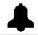
Door Open |  | 
Door Close |  | 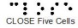
Main Entry Floor |  | 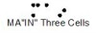
Phone |  | 
11B-407.4.7.1.4 Visible Indicators
Buttons with floor designations shall be provided with visible indicators to show that a call has been registered. The visible indication shall extinguish when the car arrives at the designated floor.
11B-407.4.7.1.5 Button Spacing
A minimum clear space of ³/₈ inch (9.5 mm) or other suitable means of separation shall be provided between rows of control buttons.
11B-407.4.7.2 Keypads
Keypads shall be identified by characters complying with Section 11B-703.5 and shall be centered on the corresponding keypad button. The number five key shall have a single raised dot. The dot shall be 0.118 inch (3 mm) to 0.120 inch (3.05 mm) base diameter and in other aspects comply with Table 11B-703.3.1.
11B-407.4.8 Car Position Indicators
Audible and visible car position indicators shall be provided in elevator cars.
11B-407.4.8.1 Visible Indicators
Visible indicators shall comply with Section 11B-407.4.8.1.
11B-407.4.8.1.1 Size
Characters shall be ¹/₂ inch (12.7 mm) high minimum.
11B-407.4.8.1.2 Location
Indicators shall be located above the car control panel or above the door.
11B-407.4.8.1.3 Floor Arrival
As the car passes a floor and when a car stops at a floor served by the elevator, the corresponding character shall illuminate.
Exception: Reserved.
11B-407.4.8.1.4 Reserved
11B-407.4.8.2 Audible Indicators
Audible indicators shall comply with Section 11B-407.4.8.2.
11B-407.4.8.2.1 Signal Type
The signal shall be an automatic verbal annunciator which announces the floor at which the car is about to stop.
Exception: For elevators that have a rated speed of 200 feet per minute (1 m/s) or less, a non-verbal audible signal with a frequency of 1500 Hz maximum which sounds as the car passes or is about to stop at a floor served by the elevator shall be permitted.
11B-407.4.8.2.2 Signal Level
The verbal annunciator shall be 10 dB minimum above ambient, but shall not exceed 80 dB, measured at the annunciator.
11B-407.4.8.2.3 Frequency
The verbal annunciator shall have a frequency of 300 Hz minimum to 3000 Hz maximum.
11B-407.4.9 Emergency Communication
Emergency two-way communication systems shall comply with Section 11B-308. Raised symbols or characters, white on a black background and Braille shall be provided adjacent to the device and shall comply with Sections 11B-703.2 and 11B-703.3. Emergency two-way communication systems between the elevator and a point outside the hoistway shall comply with ASME A17.1.
11B-407.4.10 Support Rail
Support rails shall be provided on at least one wall of the car.
11B-407.4.10.1 Location
Clearance between support rails and adjacent surfaces shall be 1¹/₂ inches (38 mm) minimum. Top of support rails shall be 31 inches (787 mm) minimum to 33 inches (838 mm) maximum above the floor of the car. The ends of the support rail shall be 6 inches (152 mm) maximum from adjacent walls.
11B-407.4.10.2 Surfaces
Support rails shall be smooth and any surface adjacent to them shall be free of sharp or abrasive elements.
11B-407.4.10.3 Structural Strength
Allowable stresses shall not be exceeded for materials used when a vertical or horizontal force of 250 pounds (1112 N) is applied at any point on the support rail, fastener, mounting device or supporting structure.

